Module Current Profile Test
Batteries can be tested at the Center for Automotive Research in the front building using the Arbin battery testing machines. The Arbin can charge and discharge a battery with current over a time period using a current profile, which is a time array of current. While doing this, it can log sensor data such as voltage readings and temperature readings. Similar in many ways to an HPPC test, however in this case, the current profile is a simulated lap. In the simulator we can create current profiles which describe the battery current over a run, these profiles can then be applied to the cell, and its characteristics can be studied.
This is useful to us in many ways, most of which have to do with model validation. While our lump cell battery model is based on fundamental thermodynamic equations, the assumptions involved with its calculations, and the error in the data fed into the model can cause discrepancies from reality. Additionally, with the current profiler we can learn about the modules in ways that we wouldn’t be able to from an HPPC test or manufacturer data sheet. For example, how heat is distributed through the 5 parallel cells in each module.

Round 1 Test: Initial Model Validation and Thermal Hotspot Testing
The goal for the first round of module current profile testing is simple, see the difference between the simulated cell versus real life temperature given the same current profile. Until data such as the second round of HPPC testing is available, we can manually adjust parameters such as the heat transfer coefficient and the thermal drop off due to temperature to match the real-life data if there is a significant discrepancy.

The current profile is taken directly from a run using the dynamic derate system from the V1 control algorithm. A throttle and speed trace from a full endurance run from the Applied Racing Dynamics lap time simulation are fed into the simulation. Running the Simulink model with these inputs creates a current profile for a full endurance run. The current profile is then saved into the MATLAB workspace and can be programmed into the Arbin testing machine.

For round 1, a single module will be tested in ambient air without insulation. The current profile will simulate a full endurance run. The run is based on the results from a proof of concept-esque dynamic derate map, powered by the velocity and throttle traces from a lap time simulation. The run is a sum of 22 identical laps of the 2025 FSAE EV endurance track. The lap time simulation was conducted in Applied Racing Dynamics, with the track map being collected using GPS data from this year’s track walk with a smartphone.

The ambient air runs will allow the losses in the lump cell model to ambient air to be analyzed. The room being very large with air conditioning allows us to assume that the air around the module remains at exactly 23.5 degrees Celsius, a reading taken by the thermocouples at the beginning of the test. This assumption of static air temperature enables the convection effects in the simulation to be compared to the test data. In the future, an insulated test might be useful to isolate the accuracy of the Battery Heat Gain block of the lump cell model, and ignore losses to convection, assuming an adiabatic experiment.

Additionally, I am planning on taking photos throughout the test with a Flir infrared camera to capture the temperature distribution through the cell, allowing information such as bus bar and contact temperature to be measured. Things such as cell manufacturing defects can cause localized hotspots in the cell, increasing the cell's temperature, as seen below. These defects cannot be spotted by thermocouples, but a thermal camera might allow us to pick them up if they’re large enough. There will also be a thermocouple on each cell on the module, allowing the individual cell temperatures to be tracked.

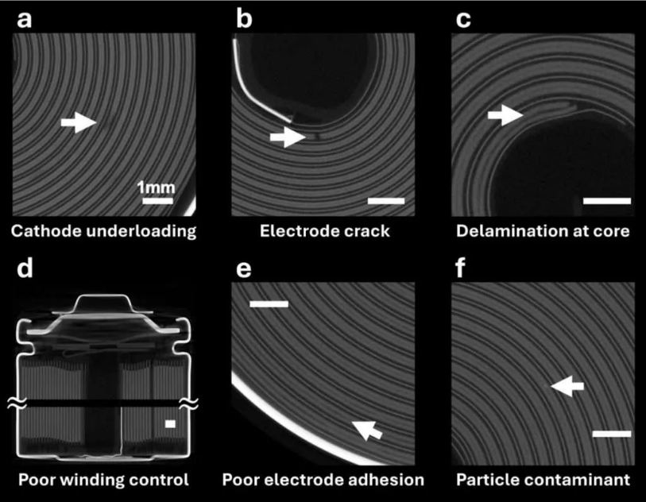
Figure 7.x
The test was conducted the morning of October 30th 2025, and was completed successfully. First, the module was connected to the Arbin battery testing machine. 5 T-type thermocouples were placed on each cell, with thermal isolation tape to increase measurement accuracy. Additionally, two voltage sensors were attached to the terminal. This is because for the Arbin to reach the ~110A peaks in the profile, current sources from the Arbin had to be wired in parallel, as each source can only output 100A. Thus, because the Arbin requires a voltage sensor for every current source, two voltage sensors were used, one per source.
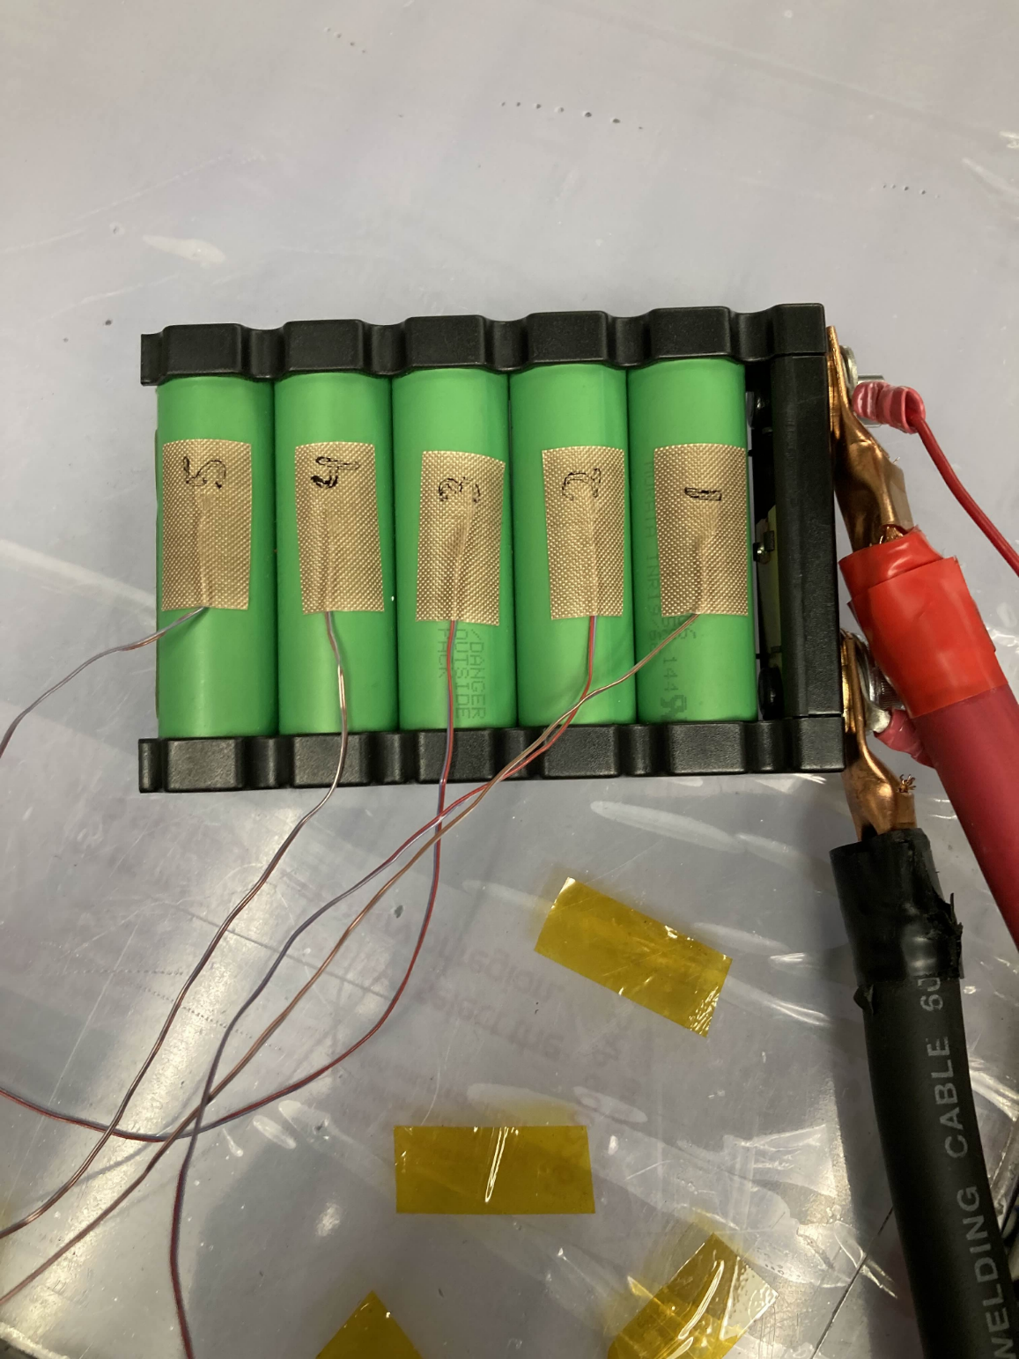
Figure 7.x
The cells were numbered as shown in the picture, with 1 being the closest to the terminals, and 5 being the farthest. This naming convention will be kept moving forwards.
The testing plan was a 5 step one. First the Arbin would let the cell rest, before charging it fully during the second step. Next, for step 3, it would once again rest to allow the voltage to reach a settling point before beginning the endurance simulation. Step 4 would be the full 22 minute endurance simulation. Step 4 had the important condition set where the test would automatically stop if the cells went below 2.5V, the minimum rated voltage for the cells. After the simulation was ended, step 5 would allow the cell to rest again before the test would be completed.
Important to note is that the module was not topped up to an SoC of 100%. This is because the initial SoC was miscalculated, thus the charging period was unable to reach a fully charged state. The OCV measured during the rest period before the test was 4.03V, indicating that the module SoC was closer to a value of 0.78% SoC, meaning the test couldn’t run to completion.
The test was able to run successfully, and shut down once the voltage sensors read 2.5V. The data was then delivered to me to post process. The results are as follows.
The temperature distribution across the cells was not exactly the same, which could be due to a number of reasons. However, I am unable to discern the reason, or if it's a cause for concern.
‘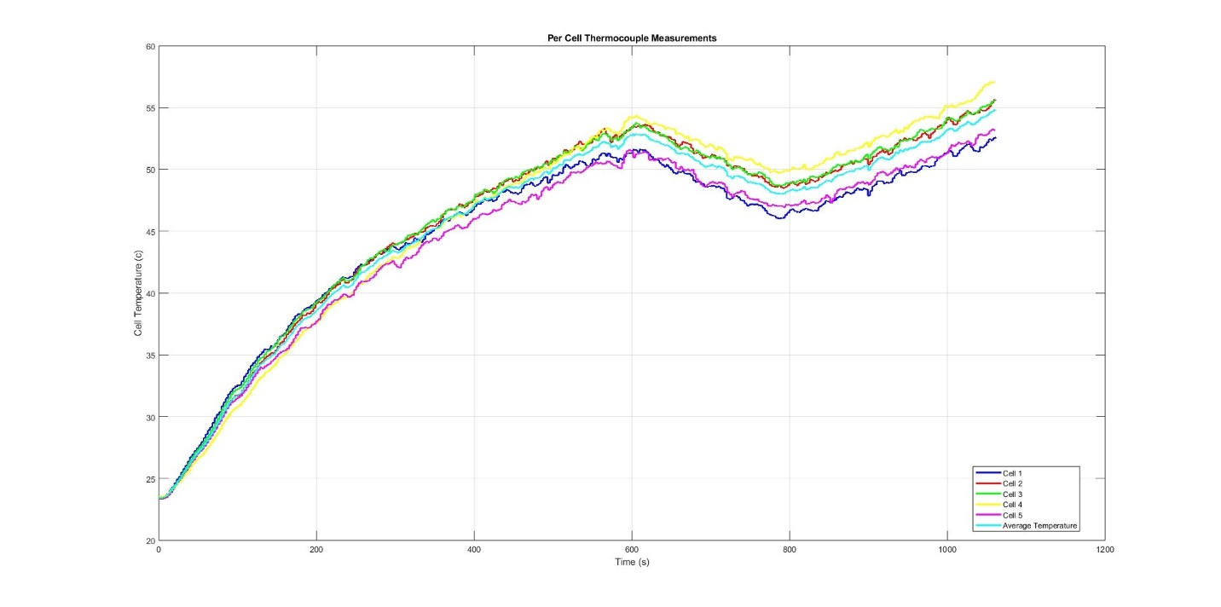
Figure 7.x
According to thermal imaging, the surfaces where the cells face each other are by far the hottest portion of the cell, as seen below. I believe this might be the cause for why cells 1 and 5 are the hottest, as they only have one side exposed to another cell, with the other being exposed to cool ambient air.

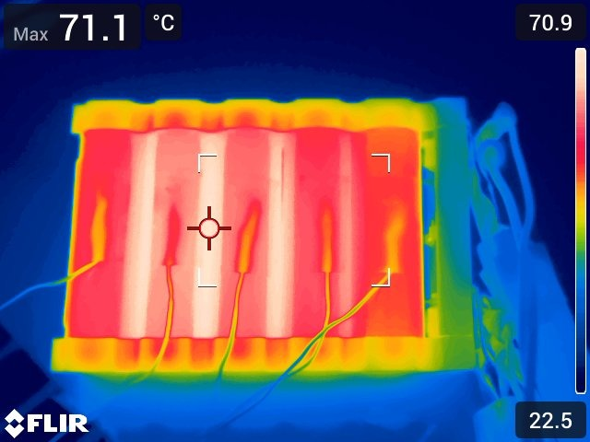
Figure 7.x
On the note of temperature distribution, the top of the cell was colder than expected, this is especially true for the locking elements such as the bolts, which I expected to be far warmer. However, this could be since the thick and long cables supplying the current acted as a heat sink.
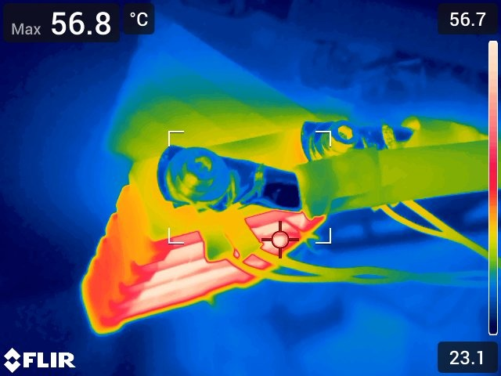
Figure 7.x
The sides were also colder than expected, however knowing the temperature of the strip connecting the cells is difficult without removing the plastic cover.
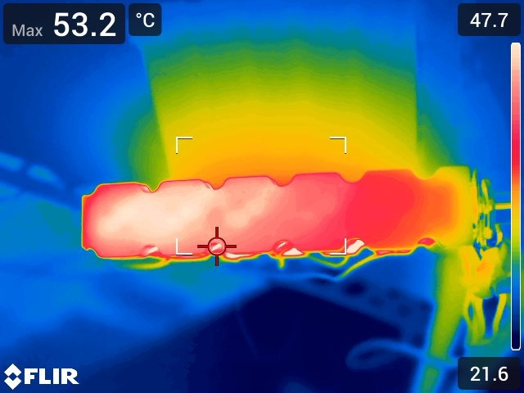
Figure 7.x
Because of the huge thermal distribution gradient on the module, where the thermistors in our cells are measuring from is extremely important. Some parts of the cell are more advantageous than others, in the sense that they would prevent us from breaching our 60 degrees celcius limit, as they would be far cooler than the hot spots. On the flip side, this could easily lead to damaging the cells. To prevent this, it would be useful to create an Arduino powered data logger to connect to the module thermistors and record their readings. Therefore, their readings could be compared to thermocouple data and thermal imaging data, to understand where on the spectrum they land.
Next, to use the thermocouple data to validate the lump cell models accuracy, some changes to the model had to be made. Because the lump cell model models a full sized pack with far more thermal mass and a different amount of area to be exposed to air, adjustments were made to model an individual 1S5P Enapaq VTC6 module. Once those changes were made, the current profile fed into the Arbin battery tester was fed into the module thermal model, and the results were recorded.
Overlaying the voltage and temperature of the simulated and real world results leads to some interesting conclusions.

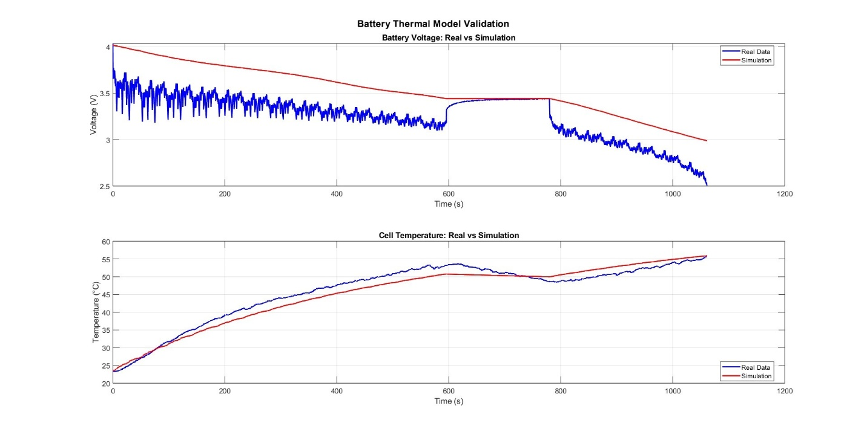
Figure 7.x
First we will look at the temperature graph, where the fit of the model for a first attempt is extremely convincing. Overall, the reported median error for the simulation was 1.96 degrees, meaning it should be accurate enough to trust and conduct simulations to develop dynamic derate systems with. In general, it heats up too slowly and cools too slowly during the pitstop. This could be remedied with testing for thermodynamic values such as the specific heat capacity. This would allow us to get a better representation of the parameters for our specific cells, instead of using values from a different type of 18650 cell from the internet. At the end of the test the temperatures converge to an error of 0.4 degrees, completely by chance.
For the cell voltage, there is a much bigger difference. This is caused by how the cell voltages are calculated. Currently, they are found by assuming the open circuit voltage is the same as the voltage when current is applied. This results in the only point where the voltages match being the pitstop after a setting period, as no current passes through the battery during these three minutes. This is because doing it this way is far simpler than creating an equivalent circuit with RC elements. For tests where a current profile is directly being fed into the model, this is acceptable as the voltage is not used for any thermodynamic calculation. However, in tests where a throttle profile is used along with the dynamic derate maps, accurately calculating pack voltage is key to being able to calculate the current needed to suit a power demand. Looking into more accurate ways of modeling pack voltage could significantly increase the accuracy of simulations where throttle position is used to calculate a battery current. This should be well within the team's capability as we already have HPPC testing data that will allow us to calculate an equivalent circuit for an array of different thermal, charging magnitude and capacity states.

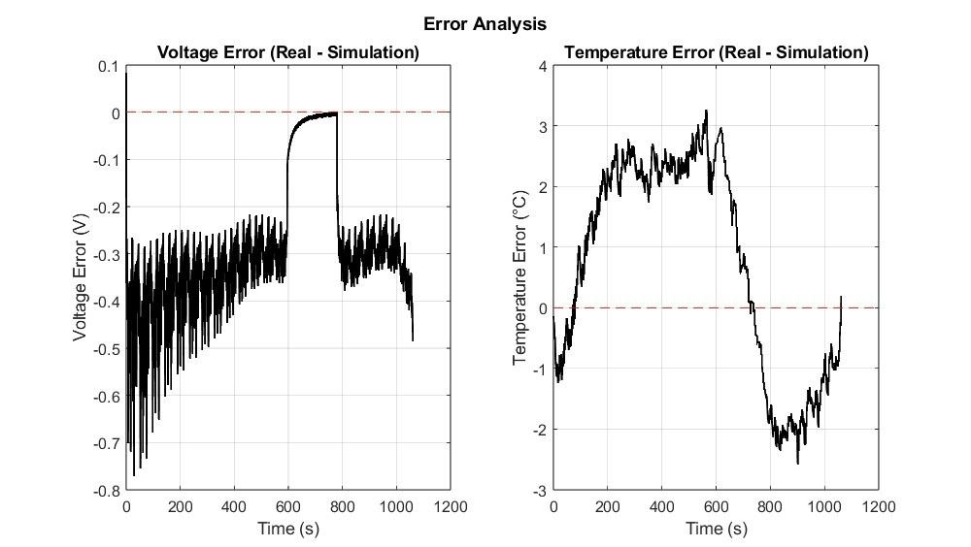
Figure 7.x

